|  |  |  |  |
| --- | --- | --- | --- |
| Keywords | Ranking Position | Page Number | URL Found |
| Digital Marketing Company In Mumbai | 2 | 3 | [www.mydigitalcrown.in](http://www.mydigitalcrown.in/) |
| SEO Company In Mumbai | 4 | 2 | [www.mydigitalcrown.in](http://www.mydigitalcrown.in/) |
| Digital Marketing Company In Kolkata | N/A | N/A | N/A |
| SEO Company In Kolkata | N/A | N/A | N/A |

**Manual Testing Report**

* **Search engine ranking of MyDigitalCrown for these keywords**

**Website Analysisx**

Total number of pages: 13

1. Home
2. About Us
3. Services

-SEO

-Digital Strategy

-PPC Advertising

-Social Media Marketing

-Content Marketing

-Web Development

-Web Design

-YouTube Promotion

4. Clints

5. Jobs

6. contact

**Errors found on the website**

TC_1:

Defect Headline: ‘Job’ menu bar is in different colour among all the menu bars in Home page.

Screenshot:

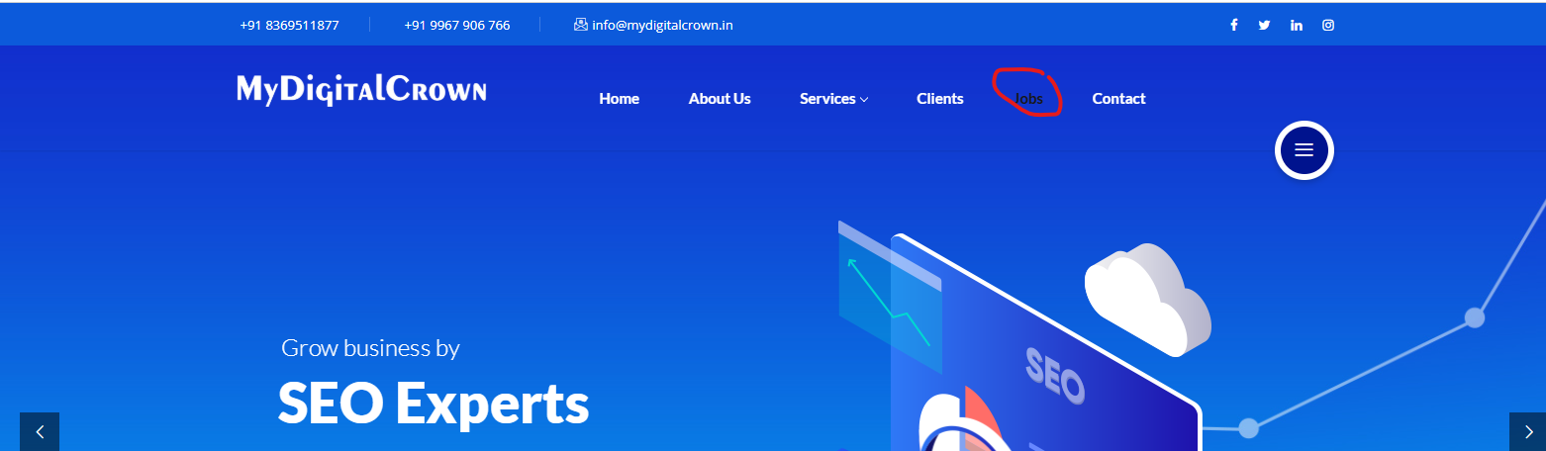

Tc_2:

Defect Headline: Linkdin is not working properly, if user click on Linkdin icon then it opens the homepage of Linkdin.

Screenshot:

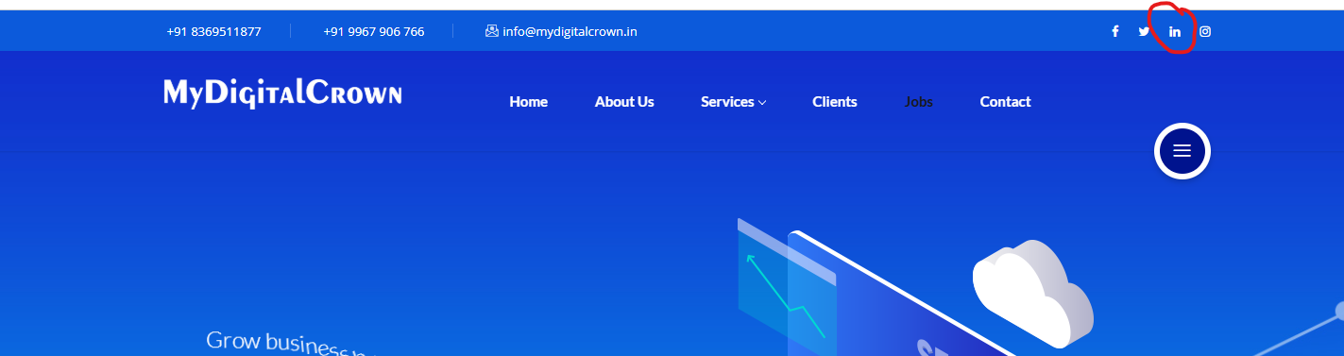

Tc_3:

Defect Headline: When user try to search for ‘Jobs Opening’ then the articles is displayed in the next page.

Screenshot:

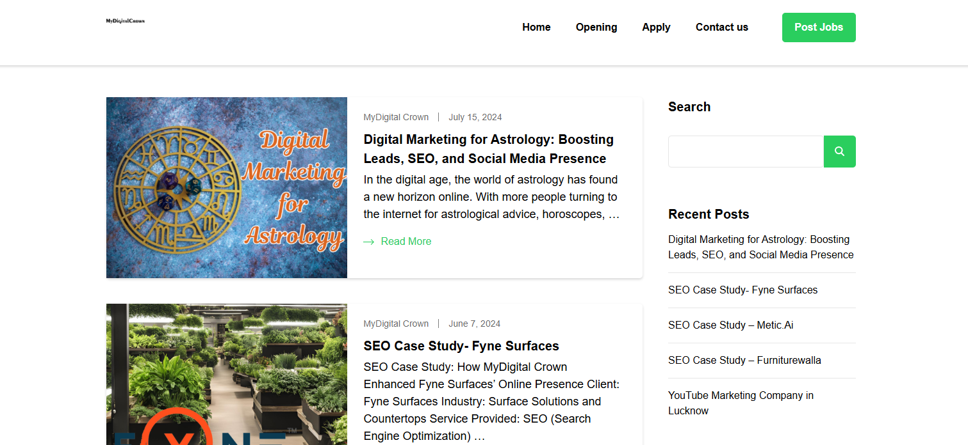

Tc_4:

Defect Headline: When user clicks on ‘apply’ button in the jobs page then it display the ‘contact page’.

Screenshot:

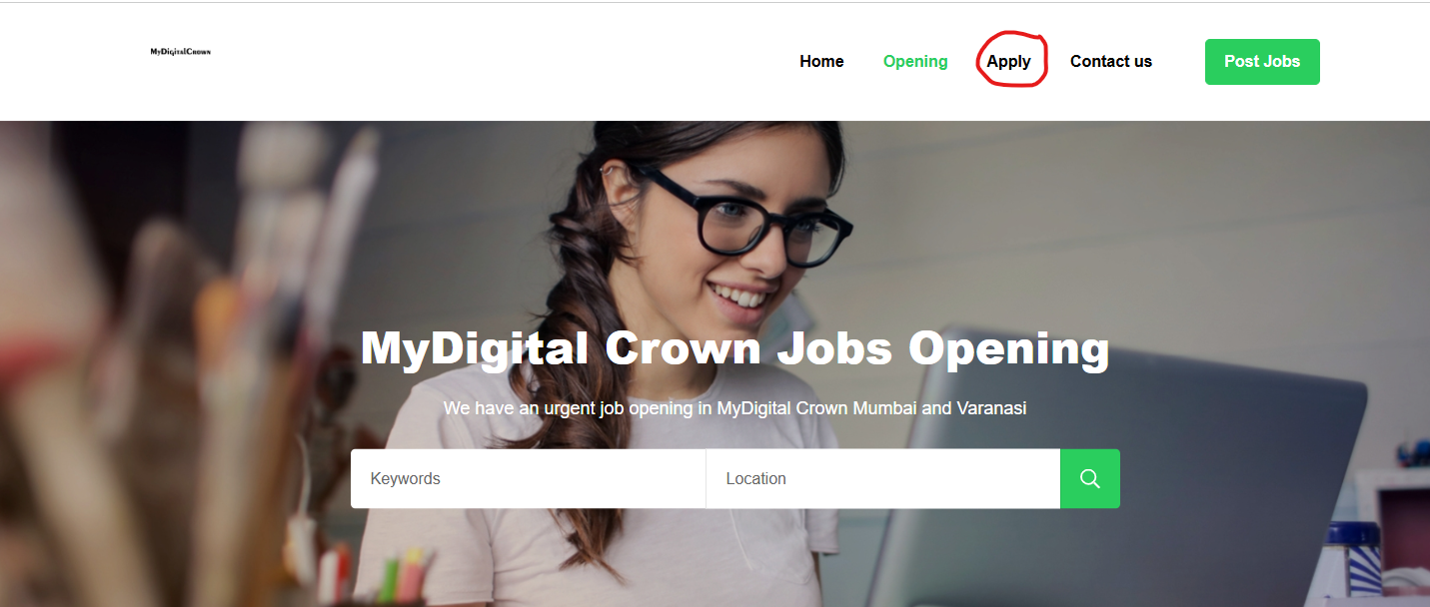

Tc_5:

Defect Headline: ’Post Job’ button is not working in the ‘Jobs’ page.

Screenshot:

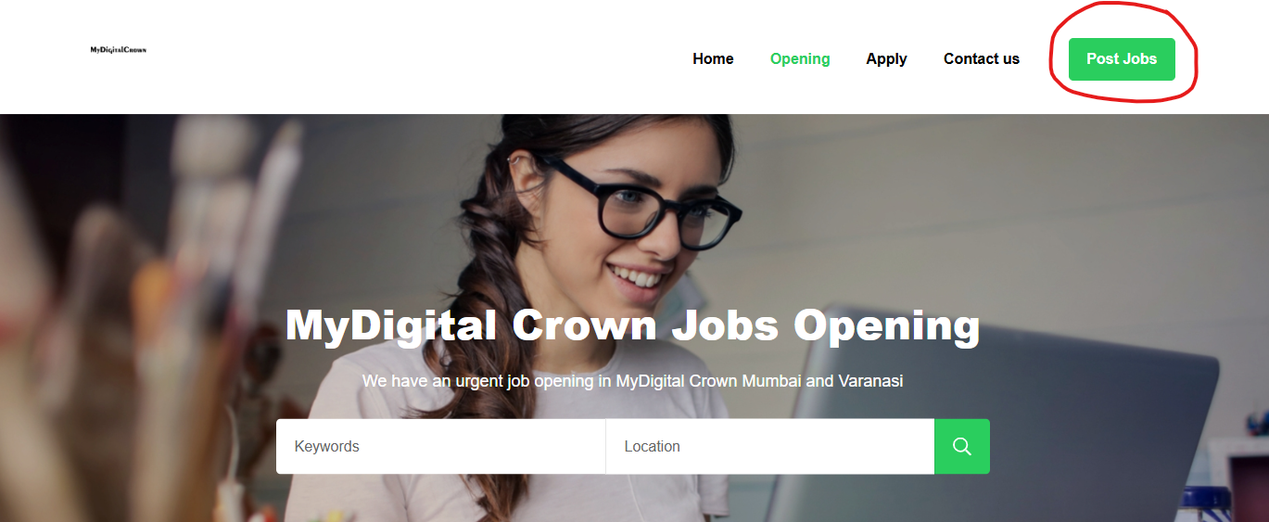

Tc_6:

Defect Headline: Service Link is not working properly.

Screenshot:

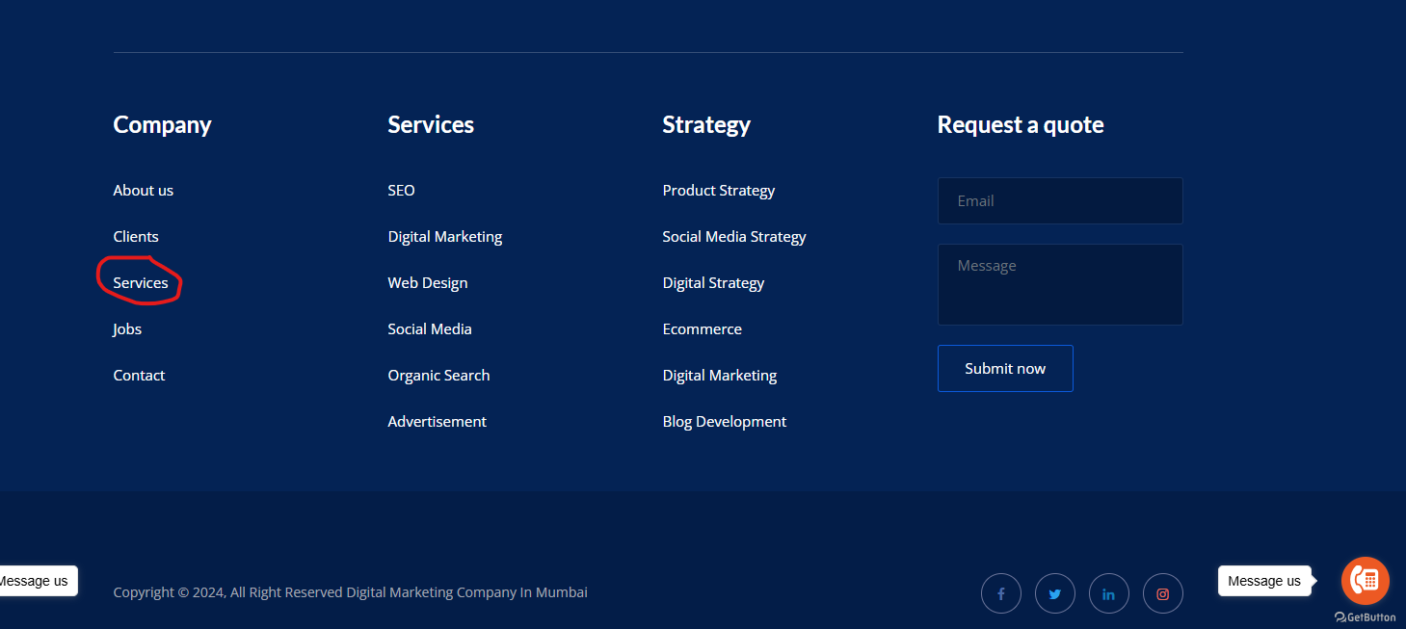

Tc_7:

Defect Headline: ‘Digital Marketing’ link is written multiple time in the application.

Screenshot:

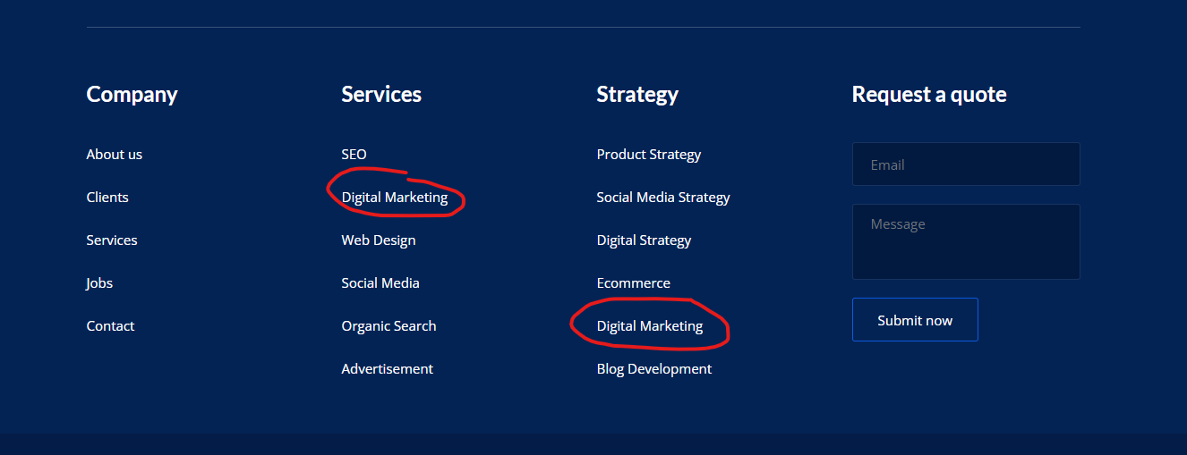

**Suggestions for improvements**

* Include Legal Pages: Add a privacy policy and terms of service to inform users about data handling practices and build trust**.**
* Content Redundancy: Certain sections repeat similar information, which can dilute the message and overwhelm visitors. Streamlining content to be concise and targeted would enhance readability.
* Grammatical Errors: The website contains multiple grammatical mistakes and awkward phrasing, such as “We’re a Best SEO Agency in Mumbai.” Such errors can undermine the credibility of the business.